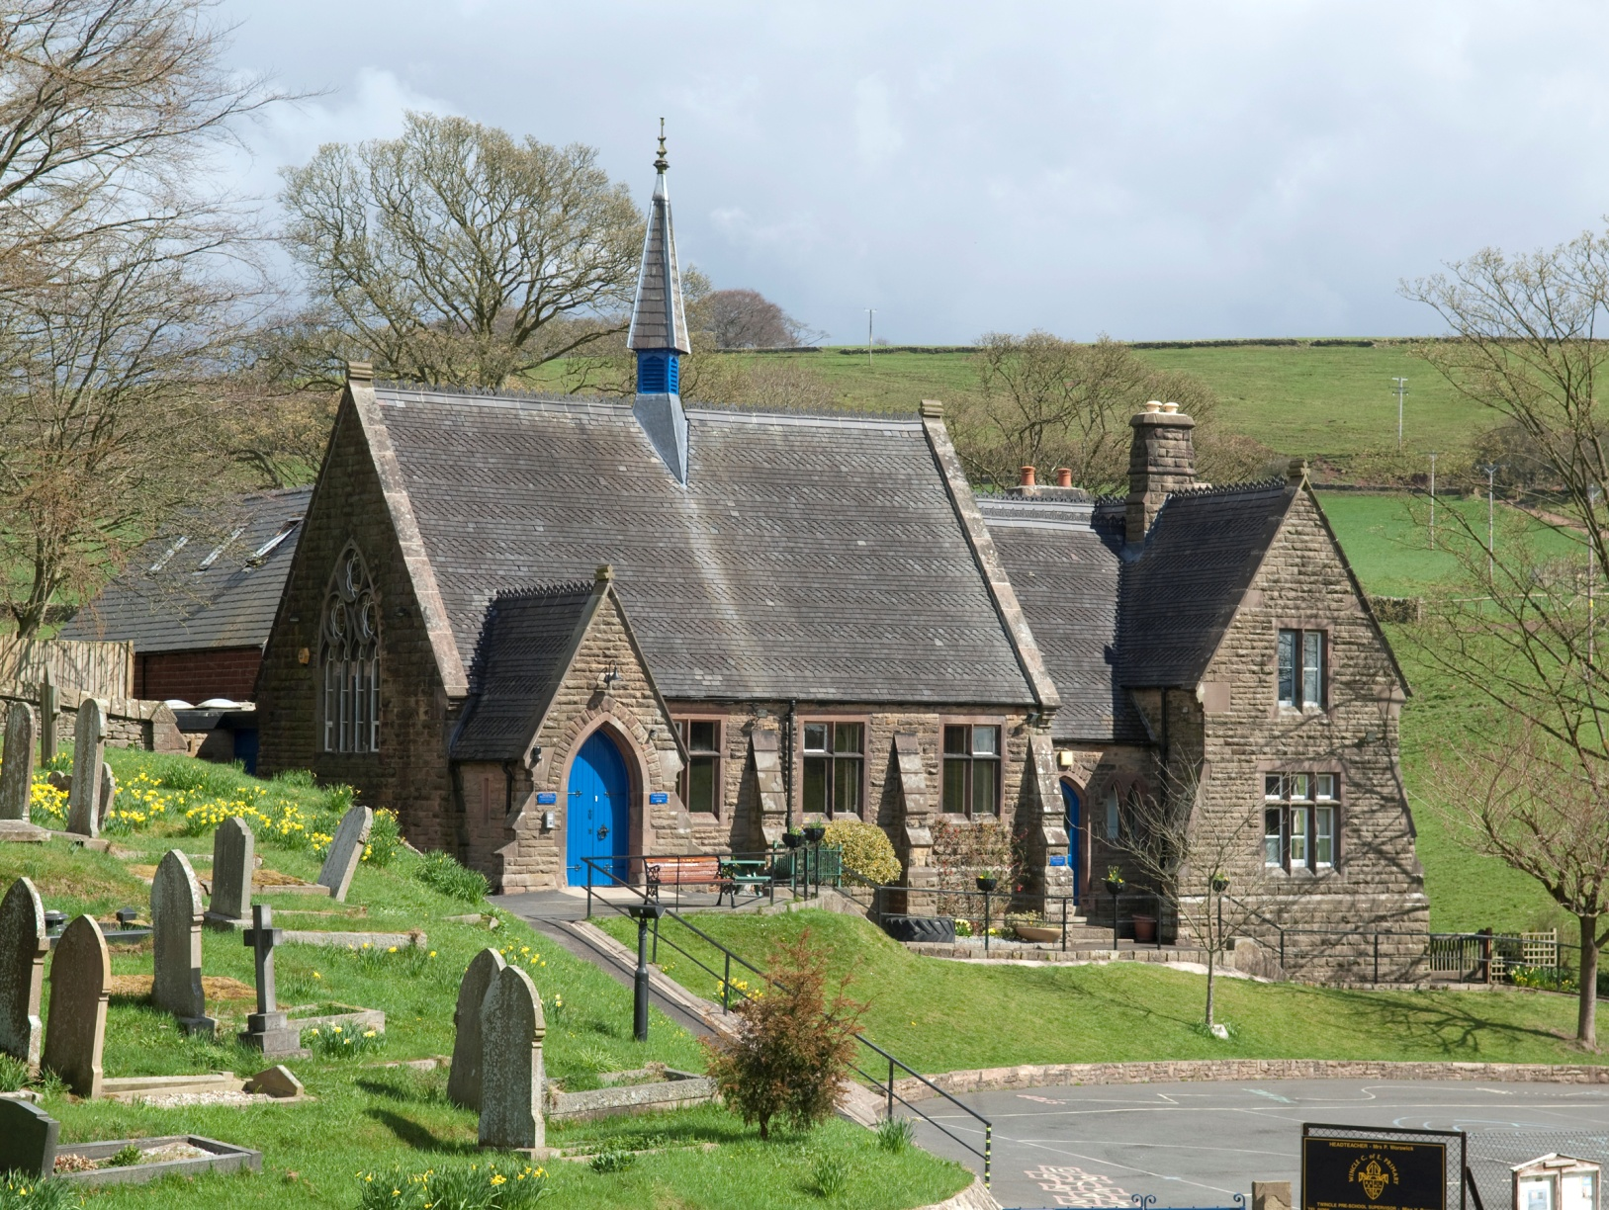

RSE Policy
Wincle CE Primary School

Version: DRAFT

Updated: June 2022

Wincle CE Primary School
Wincle
Macclesfield
Cheshire
SK11 0QH
Tel: 01260 212592
Headteacher: Mrs S Smith
Chair of Governors: Dr J Miller

Version control
Date updated: | Brief summary of changes:
June 2022 | The schemes of work have been removed and saved as separate documents.
Our school’s vision:
Wincle School creates an enriching and outstanding rural education, nurturing the whole individual: body, mind and soul, inspiring rounded, happy, courageous children who exhibit a passion for learning, a confident faith, a loving concern for community and an inclusive respect for all.
We encourage our staff and pupils to ‘Shine like Stars’ (Philippians 2:15) and to do this run with the following acronym:

PSHE (incorporating RSE) policy

Introduction
Personal, social, health and economic (PSHE) education is an important and necessary part of all pupils’ education which supports the nurturing of the whole individual: body, mind and soul. Our aim is to provide our pupils with the confidence required to cope with the pressures of daily life and to display a loving concern and the upmost respect for all around them.

As a school, we have five core values of perseverance, respect, hope, compassion and integrity. These core values are embedded within our PSHE teaching and are promoted in all aspects of school life.

It is a non-statutory subject with no standardised frameworks or programmes of study. PSHE can encompass many areas of study and it is for schools to tailor their local PSHE programme to reflect the needs of their pupils to equip them with a sound understanding of risk and with the knowledge and skills necessary to make safe and informed decisions.

PSHE education should build, where appropriate, on any content already outlined in the national curriculum, the basic school curriculum and in statutory guidance on: drug education, financial education, relationship & sex education (RSE) and the importance of physical activity and diet for a healthy lifestyle.

This policy has been produced through consultation with teaching staff, parents and the governing body and complies with The Relationships Education, Relationships and Sex Education and Health Education (England) Regulations 2019, made under sections 34 and 35 of the Children and Social Work Act 2017 and the Equality Act (2010). It also takes into consideration the guidance offered in the document Valuing All God’s Children July 2019 (Church of England Education Office).

Relationships & Sex Education
To embrace the challenges of creating a happy and successful adult life, pupils need knowledge that will enable them to make informed decisions about their wellbeing, health and relationships and to build their self-efficacy. Pupils can also put this knowledge into practice as they develop the capacity to make sound decisions when facing risks, challenges and complex contexts. Everyone faces difficult situations in their lives. These subjects can support young people to develop resilience, to know how and when to ask for help, and to know where to access support.

From September 2020, The Relationships Education, RSE, and Health Education (England) Regulations have made Relationships Education compulsory in all primary schools. Sex education is not compulsory in primary schools although in this school, we will teach aspects of sex education, which goes beyond the national curriculum for science, in Year 5/6. This will focus on the changes that occur during puberty, how babies are conceived and menstruation.

Aims
- To be aware of children’s needs and understanding at various developmental stages and respond appropriately.
- To help children to understand themselves, have a positive self-image, and have good feelings and attitudes towards living and loving.
- To ensure effective co-ordination between phases of education which will support the continuity of curriculum experience and provision in matters relating to sex education.
- To promote an understanding of the nature of personal relationships, love and family life.
- To develop positive attitudes towards all types of family relationships, including same-sex relationships or relationships which include trans people. For example, children regularly watch BBC Newsround (which highlights issues regarding relationships and gender in a positive, child-friendly way) and we have a variety of books available containing stories about different types of family backgrounds – Amazing Grace, Julian is a Mermaid, The Boy In The Dress, Heather Has Two Mummies etc. All discussions around these books will be handled sensitively and, in an age,-appropriate fashion.
- To develop an awareness of the importance of sensitivity for the feelings of others and of the responsibilities individuals have to society and to one another, by laying the foundations of responsible, moral attitudes and behaviour.
Eph. 4:32 ‘be kind and compassionate to one another’ or Eph. 4:2 ‘be completely humble and gentle, be patient, bearing with one another in love,’ or ‘love your neighbour as yourself.’ Matt.22:39.
- To provide information relevant to physical, emotional and social aspects of sexual development appropriate to the individual’s age and level of maturity. For example, we will teach children in year 5/6 about the effects of puberty and how to stay safe online. We will respond with sensitivity to the natural curiosity of young children and answer any questions in an age appropriate way.
- Where necessary, to provide objective and balanced information which will lead children to an understanding or the attitudes and behaviour in present day society.
- To foster the personal confidence of the individual to talk about any issue or personal preference, including sexuality, using the appropriate vocabulary as and when appropriate.
- To establish a framework and mechanisms, which encourage efficient co-operation between institutions and their wider community, including parents and appropriate support agencies.
- To develop a curriculum in the broadest sense, which reflects equal esteem for girls and boys, men and women.
- To inform, in an age appropriate manner, about the influence of digital and social media.

Learning & teaching
Our PSHE/RSE will be delivered through:
- Timetabled PSHE lessons *see timetables below
- Health & safety/first aid workshops
- E safety workshops/NSPCC workshops
- Residential visits
- Through other subjects/curriculum areas
- Through school events and activities
- Through pastoral care and guidance
- Through learning with the School Health team

All staff are encouraged to develop a repertoire of flexible, active learning methods. These may include:
- Circle Time
- Working in different group settings
- Problem solving & team challenges
- Setting our own success criteria
- Developing ground rules
- Pupil Voice
- Drama and role play

Useful teaching strategies:

Lesbian, Gay, Bisexual and Transgender (LGBT)
In our school, we will inform children, in appropriate ways, that some people identify as lesbian, gay, bisexual or transgender. The Department for Education recommends that it is integral throughout the programmes of study. We will ensure that our teaching is sensitive, age-appropriate and delivered with reference to the law.

SEN
Relationships Education, RSE and Health Education (inc. Drugs Education) must be accessible for all pupils. This is particularly important when planning teaching for pupils with special educational needs and disabilities as they represent a large minority of pupils. High quality teaching that is differentiated and personalised will be the starting point to ensure accessibility. The school will be mindful of the preparing for adulthood outcomes as set out in the SEND code of practice, when preparing these subjects for those with SEND.

Monitoring, Assessment Recording & Reporting
PSHE Education and Relationships & Sex Education (inc. Drugs Education) will be monitored by the subject leader (Mrs Massey) and a named member of the governing board (Mrs Katy Powell). Any decisions or alterations to policy will be made by the Pupil Welfare committee of the governing body following guidance by the subject leader and head teacher. This policy will be reviewed annually.

As well as fulfilling their legal obligations, the head teacher and governing body will make sure that:
- all pupils make progress in achieving the expected educational outcomes;
- the subjects are well led, effectively managed and well planned;
- the quality of provision is subject to regular and effective self-evaluation;
- teachers explore how new pedagogies and technology can be fully utilised to support the subjects;
- teaching is delivered in ways that are accessible to all pupils with SEND;
- clear information is provided for parents on the subject content and the right to request that their child is withdrawn; and,
- the subjects are resourced, staffed and timetabled in a way that ensures that the school can fulfil its legal obligations.
- safeguarding is a high priority within a balanced curriculum

Foundation governors will also have wider responsibilities in relation to maintaining and developing the religious ethos of the schools.

In addition, the subject leader will:
- raise awareness amongst all staff of their contribution to the children’s personal and social development, including relationships
- establish a shared view of best practice to which all pupils are entitled
- lead policy development
- agree the main priorities for the children’s personal and social development and identify the major opportunities for meeting these priorities across the curriculum
- provide appropriate support and training for staff
- monitor and evaluate the programme, including the use of outside agencies, and children’s responses to the programme
- carry out a continuous process of review and development of the programme as part of the annual cycle of school improvement
- order and monitor resources

Assessment in Relationships and PSHE Education (inc. Drugs Education) does not imply that children are failing as people or citizens. It is not a judgement on the worth, personality or value of an individual child or their family. A statement of each child’s progress is reported to parents in the end of year reports.

The Right to be excused from sex education (commonly referred to as the right to withdraw)
Relationships Education, through PHSE, is a statutory part of the curriculum and parents do not have the right to withdraw their child from any aspect of that provision other than sex education.

Parents have the right to request that their child be withdrawn from some or all of sex education delivered as part of statutory RSE. Before granting any such request, the head teacher would request a meeting, as good practice to:
- discuss the request with the parent and, as appropriate, with the child to ensure that their wishes are understood and to clarify the nature and purpose of the curriculum.
- discuss with the parent the benefits of receiving this important education and any detrimental effects that withdrawal might have on the child. This could include any social and emotional effects of being excluded, as well as the likelihood of the child hearing their peers’ version of what was said in the classes, rather than what was directly said by the teacher.
Once those discussions have taken place, except in exceptional circumstances, the school would respect the parents’ request to withdraw the child and automatically withdraw a pupil from any sex education delivered, other than as part of the science curriculum. There is no right to withdraw from the National Curriculum.

If a child is excused from sex education, it is the school’s responsibility to ensure that the pupil receives appropriate, purposeful education during the period of withdrawal.

For the vast majority of pupils with SEND, including those with education, health and care plans, their SEND should not be a consideration in deciding whether to grant a parental request, however there may be exceptional circumstances where the head teacher will want to take a pupil’s SEND into account when making this decision.

Drugs Education & Substance Misuse

Introduction
It is essential for our children to be educated fully about the misuse of drugs and substances in order to prepare them for life as teenagers and adults. The ethos of our school is based upon love and respect for one another and we regard ourselves as a family unit. It is within such a close knit moral framework that we would seek to influence and educate, raising the issue of drug awareness through the ‘hidden curriculum’ as well as directly through topics in science lessons.

Statement of Policy
The teachers, non-teaching staff and governors of our School:
- condones neither the misuse of drugs and alcohol by members of the school, nor the illegal supply of these substances.
- is committed to the health and safety of its pupils and will take action to safeguard their well-being.
- acknowledges the importance of its pastoral role in the welfare of young people.
- acknowledges the need to be aware and sensitive to the fact that some children may be living with drug-using parent/carers.

In response to shared concerns both locally and nationally, we wish to state that as part of our care for the welfare of our pupils, we believe that we have a duty to inform and educate young people on the consequences of drug use (including tobacco) and misuse.

Whilst we acknowledge that nationally the numbers of young people who misuse substances is rising dramatically and not wishing to be alarmist, it is seen as important to recognise that larger numbers of young people choose not to misuse substances.

Aims
We believe and support the following aims:-
- to enable pupils to make healthy, informed choices by increasing knowledge, challenging attitudes and developing and practising skills.
- to provide accurate information and increase understanding about the implications and possible consequences of misuse.
- to widen understanding about related health and social issues.
- to provide up to date information to parents.
- headteacher to liaise with the appropriate services and arrange INSET for staff as and when appropriate.
- staff to be aware that generally the LA recommends that substance use and misuse issues are best dealt with by trained staff who can gauge the most appropriate level of response to their questions and comments.

Drug abuse
If legal drugs are brought onto the premises, they will be confiscated and locked in a secure area by the head teacher. Parents will be informed. A repeat occurrence would result in a fixed term exclusion, subject to governor approval. If illegal drugs are brought onto the premises, they will be confiscated and locked in a secure area by the head teacher. The Police will be informed and under safeguarding arrangements, social services will be informed. Action taken thereafter will be under the guidance and support of other agencies. Other substances may be confiscated and disposed of by an external agency. If this is the case, the school will write to the parents within seven days confirming that this has taken place. (See note below).
Note
Schools do have the power to confiscate inappropriate items, including a substance or any other drug whatever its legal status, in line with the school's Relationships & Behaviour policy. They do not have to return such confiscated substances, although illegal substances would be handed over to the appropriate authorities.

Health and Safety
In view of the rurality of the school, the school site should be regularly checked for signs of drug use ie syringes, these should be removed with appropriate caution.

Expectations by the end of key stage two:

Relationships

Families and people who  care for me | Pupils should know  • that families are important for children growing up because they can give love, security and stability.  • the characteristics of healthy family life, commitment to each other, including in times of difficulty, protection and care for children and other family members, the importance of spending time together and sharing each other’s lives.  • that others’ families, either in school or in the wider world, sometimes look different from their family, but that they should respect those differences and know that other children’s families are also characterised by love and care.  • that stable, caring relationships, which may be of different types, are at the heart of happy families, and are important for children’s security as they grow up.  • that marriage represents a formal and legally recognised commitment of two people to each other which is intended to be lifelong.  • how to recognise if family relationships are making them feel unhappy or unsafe, and how to seek help or advice from others if needed
Caring friendships | Pupils should know  • how important friendships are in making us feel happy and secure, and how people choose and make friends.  • the characteristics of friendships, including mutual respect, truthfulness, trustworthiness, loyalty, kindness, generosity, trust, sharing interests and experiences and support with problems and difficulties.  • that healthy friendships are positive and welcoming towards others, and do not make others feel lonely or excluded.  • that most friendships have ups and downs, and that these can often be worked through so that the friendship is repaired or even strengthened, and that resorting to violence is never right.  • how to recognise who to trust and who not to trust, how to judge when a friendship is making them feel unhappy or uncomfortable, managing conflict, how to manage these situations and how to seek help or advice from others, if needed.
Respectful relationships | Pupils should know  • the importance of respecting others, even when they are very different from them (for example, physically, in character, personality or backgrounds), or make different choices or have different preferences or beliefs.  • practical steps they can take in a range of different contexts to improve or support respectful relationships.  • the conventions of courtesy and manners.  • the importance of self-respect and how this links to their own happiness.  • that in school and in wider society they can expect to be treated with respect by others, and that in turn they should show due respect to others, including those in positions of authority.  • about different types of bullying (including cyberbullying), the impact of bullying, responsibilities of bystanders (primarily reporting bullying to an adult) and how to get help.  • what a stereotype is, and how stereotypes can be unfair, negative or destructive.  • the importance of permission-seeking and giving in relationships with friends, peers and adults.
Online relationships | Pupils should know  • that people sometimes behave differently online, including by pretending to be someone they are not.  • that the same principles apply to online relationships as to face-to-face relationships, including the importance of respect for others online including when we are anonymous.  • the rules and principles for keeping safe online, how to recognise risks, harmful content and contact, and how to report them.  • how to critically consider their online friendships and sources of information including awareness of the risks associated with people they have never met.  • how information and data is shared and used online.
Being safe | Pupils should know  • what sorts of boundaries are appropriate in friendships with peers and others (including in a digital context).  • about the concept of privacy and the implications of it for both children and adults; including that it is not always right to keep secrets if they relate to being safe.  • that each person’s body belongs to them, and the differences between appropriate and inappropriate or unsafe physical, and other, contact.  • how to respond safely and appropriately to adults they may encounter (in all contexts, including online) whom they do not know.  • how to recognise and report feelings of being unsafe or feeling bad about any adult.  • how to ask for advice or help for themselves or others, and to keep trying until they are heard.  • how to report concerns or abuse, and the vocabulary and confidence needed to do so.  • where to get advice e.g. family, school and/or other sources.

Physical health and wellbeing

Mental wellbeing | Pupils should know  • that mental wellbeing is a normal part of daily life, in the same way as physical health.  • that there is a normal range of emotions (e.g. happiness, sadness, anger, fear, surprise, nervousness) and scale of emotions that all humans experience in relation to different experiences and situations.  • how to recognise and talk about their emotions, including having a varied vocabulary of words to use when talking about their own and others’ feelings.  • how to judge whether what they are feeling and how they are behaving is appropriate and proportionate.  • the benefits of physical exercise, time outdoors, community participation, voluntary and service-based activity on mental wellbeing and happiness.  • simple self-care techniques, including the importance of rest, time spent with friends and family and the benefits of hobbies and interests.  • isolation and loneliness can affect children and that it is very important for children to discuss their feelings with an adult and seek support.  • that bullying (including cyberbullying) has a negative and often lasting impact on mental wellbeing.  • where and how to seek support (including recognising the triggers for seeking support), including whom in school they should speak to if they are worried about their own or someone else’s mental wellbeing or ability to control their emotions (including issues arising online).  • it is common for people to experience mental ill health. For many people who do, the problems can be resolved if the right support is made available, especially if accessed early enough
Internet safety and harms | Pupils should know  • that for most people the internet is an integral part of life and has many benefits.  • about the benefits of rationing time spent online, the risks of excessive time spent on electronic devices and the impact of positive and negative content online on their own and others’ mental and physical wellbeing.  • how to consider the effect of their online actions on others and know how to recognise and display respectful behaviour online and the importance of keeping personal information private.  • why social media, some computer games and online gaming, for example, are age restricted.  • that the internet can also be a negative place where online abuse, trolling, bullying and harassment can take place, which can have a negative impact on mental health.  • how to be a discerning consumer of information online including understanding that information, including that from search engines, is ranked, selected and targeted.  • where and how to report concerns and get support with issues online
Physical health and  fitness | Pupils should know  • the characteristics and mental and physical benefits of an active lifestyle.  • the importance of building regular exercise into daily and weekly routines and how to achieve this; for example walking or cycling to school, a daily active mile or other forms of regular, vigorous exercise.  • the risks associated with an inactive lifestyle (including obesity).  • how and when to seek support including which adults to speak to in school if they are worried about their health.
Healthy eating | Pupils should know  • what constitutes a healthy diet (including understanding calories and other nutritional content).  • the principles of planning and preparing a range of healthy meals.  • the characteristics of a poor diet and risks associated with unhealthy eating (including, for example, obesity and tooth decay) and other behaviours (e.g. the impact of alcohol on diet or health).
Drugs, alcohol and tobacco | Pupils should know  • the facts about legal and illegal harmful substances and associated risks, including smoking, alcohol use and drug-taking.
Health and prevention | Pupils should know  • how to recognise early signs of physical illness, such as weight loss, or unexplained changes to the body.  • about safe and unsafe exposure to the sun, and how to reduce the risk of sun damage, including skin cancer.  • the importance of sufficient good quality sleep for good health and that a lack of sleep can affect weight, mood and ability to learn.  • about dental health and the benefits of good oral hygiene and dental flossing, including regular check-ups at the dentist.  • about personal hygiene and germs including bacteria, viruses, how they are spread and treated, and the importance of handwashing.  • the facts and science relating to allergies, immunisation and vaccination
Basic first aid | Pupils should know:  • how to make a clear and efficient call to emergency services if necessary.  • concepts of basic first-aid, for example dealing with common injuries, including head injuries.
Changing adolescent body | Pupils should know:  • key facts about puberty and the changing adolescent body, particularly from age 9 through to age 11, including physical and emotional changes.  • about menstrual wellbeing including the key facts about the menstrual cycle.

